CLO Productions Presents
CINDY-LEE
in a Musical Comedy Montage
THE BLONDE SONGBOOK
Celebrating the Lives and Work of Hollywood’s Most Beloved Blondes
www.cloproductions.com
Musical Director: REGAN RYZUK
Danny’s Skylight Room Cabaret
www.dannysgrandseapalace.com
346 West 46th Street (between Eighth & Ninth Avenues)
(212) 265-8133
June 7th, 14th & 21st @ 7 PM; June 23rd @ 9:15 PM
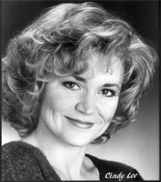
CINDY-LEE is a vivacious, buxom blonde who starts her show, The Blonde Songbook, with a high-energy version of “Cuz I’m A Blonde.” Although the voice is a little sharp and overpowered by the music, you still feel confident that she can pull this off because she is so full of fun and playfulness. And she promises to give you songs performed by some of our favorite blondes - Judy Holliday, Marlene Dietrich, Marilyn Monroe, Peggy Lee, Doris Day and Rosemary Clooney just to name a few. And then suddenly she sings Frank Loesser’s “I Wish I Didn’t Love You So” and turns the whole thing around. You realize that this lady can really sing! And whether she’s tangoing with her Musical Director Regan Ryzuk, sharing anecdotes and doing impressions of the blondes, hauling a harpoon, or telling blonde jokes, CINDY-LEE won’t quit until you’re having as much fun as she is. The Blonde Songbook is an impressive effort and a delight to experience.
- Laurie Lawson -

