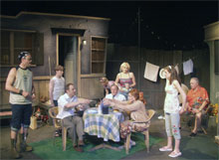
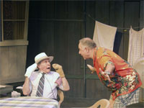
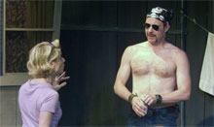
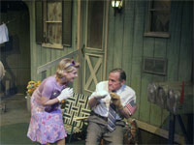
Blue Heron Theatre
presents
TRAILERVILLE
By JOHN DUFRESNE
Blue Heron Arts Center
123 E. 24 St., NYC
Tickets: (212) 868-4444 or www.smarttix.com
Info.: www.blueheron-nyc.org, www.trailerville.com
June 3 – 26, 2005
Directed by WAYNE MAUGANS
Costumes MARTIN T. LOPEZ
Lighting JESSICA LYNN HINKLE
Sets DANIEL ETTINGER
Sound VERA BEREN
Stage Manager ISAAC SCRANTON
Press Representative JIM BALDASSARE
Cast
Bobby – Ron Faber
Merdelle – Ann Hillary
Arlis – Peter Waldren
Pug – Lenore Zahn
Bromo – Christian Kohn
Theron – Miles Purinton
Kristie – Greta Sleeper
Kitty Bit – Michele Ammon
Willis – Erik Kever Ryle
TRAILERVILLE is set in a Northern Louisiana mobile home community, but it tells the kind of story that transcends place, time and economics. On the surface a simple story of love and aging, what playwright Dufresne actually offers is a deceptively complex, bittersweet and realistic tale about the different manifestations of affection and the human sense of obligation that both enriches and deprives lives of joy or fulfillment.
Taking place over a Labor Day weekend, and with snippets of the Telethon seeping through from a television, the actual action takes place in a communal outdoor space between the homes occupied by Merdelle and Bobby, and Arlis and his family. Merdelle and Bobby have come to TRAILERVILLE after disposing of prized possessions and selling their house to son, Willis and his wife, Kitty Bit. Neighbor Arlis lives with daughter, Pug, her boyfriend, Bromo, and three grandchildren, one of whom, Theron, is pining for Kristie, who is set to move away in days. Bobby has Alzheimer’s, and is deteriorating rapidly despite Merdelle’s attempts to nurse him. Arlis has come to love Merdelle, but she still loves Bobby.
Small slices of all of the relationships are part of the play, but the crux of the action revolves around whether or not Bobby can and should remain home. To be frank, there is not any new ground covered or particularly unique perspectives at work in TRAILERVILLE. Bobby’s Alzheimer’s is just part of his character, and right now it is impacting the lives of both his family and his neighbors. What Dufresne has done is to choose the breaking point as the timeframe for his action. Taken in that context, the production itself is rather respectable.
The entire cast is good, and age-appropriate, but Ron Faber, Ann Hillary and Peter Waldren resonate particularly effectively as the three points of the TRAILERVILLE love triangle. Perhaps most notably, Faber, as Bobby, does wonders with facial expressions and other more courageous physical exposure to convey the cloud that has overtaken his character’s mind. The appearance in Act 2 of Erik Kever Ryle and Michele Ammon as the bible-thumping duo of Willis and Kitty Bit adds some genuine comic relief to what is otherwise a rather sad play. Both the sets and the costumes suggest folks that are living within their limited means, but who never fail to personalize the experience. Wayne Maugans direction keeps us engrossed, even when it feels like we are sitting there waiting for a train wreck to happen.
Not happy material, but a sharp touch of reality, TRAILERVILLE delivers what it promises.
- Kessa De Santis -

